**ChetuGlobalATS-INTL**

**QA Environment Details**

**Project Details**:-

* **URL:-** <http://betaatsservice.chetu.com/>
* **Credentials:-** All Authorized members

**Database Details**:-

* **Server:-**dbprod\sql2017
* **Password:-** CH$79Tug78G
* **Database Name:-** atsbeta

**FTP Account Details**:-

* **HostName**      :               dbprod
* **Port**      :               21
* **User**      :               AtsBeta
* **Pass**     :               CH$79Tug78G

**Production Details**

**Project Details**:-

* **URL:-** <http://atsservice.chetu.com/>
* **Credentials:-** All Authorized members

**Database Details**:-

* **Server:-**APPDB01\APPDB01
* **Password:-** IT5ngr13v@123
* **Database Name:-** ats

**FTP Account Details**:-

* **IP**      :               10.0.0.32
* **Host :** ats
* **Port**     :               990
* **User**     :               appdb01ftp
* **Pass**     :               a**dB01$@f6p2

**Description of the project**

**Login Page:-**

* Firstly, there is the **Login Page** which authenticate the user to use the application.
* When someone get logged in then there are twenty six tabs.

**Resourcing Tab:-**

* On Dashboard, there is a grid which contains all the record of requests that has been made till now, which we also call Resourcing.
* **New Resource Request:**This option is used to issue new request . The dialog box includes Due Date, Technology, Resource type, experience and priority of the request. The request can be issued by FMs and admin.

* **In-Process**: This pop up shows all the requests which are in process. In process requests are those requests which are assigned to some Jobs TL for processing.

* **Export Excel:** The data which is display on the frontend can be exported to excel with the help of this option.
* **Opening Allotment:** A request issued can be assigned to some Jobs TL for further processing.

**Opening Tab:-**

* This module contains Request in three categories namely-In-Process, Complete and Offered
* Under shortlisted caption we will get all the records of the candidate that has been currently linked to the given Opening id.
* Search candidate option is used to link other candidates to the given Opening Id.

**Hiring Candidate Tab:-**

* This module contains those records who are ready for CBT(Computer Based Test). These candidate will then be available for linking to an opening.

**Track Candidate tab:-**

* This module is use to register new candidate. The Add candidate form contains all necessary information such as mobile no, email id, dob etc to be mandatory.
* Also from this module we can send mass sms/mail to the selected or all candidates.

**Naukri Portal tab:-**

* If a candidate has registered on the naukri.com then that data can be linked to ATS application through this module.

**Offer tab:-**

* When a candidate is moved from Opening section to Offer, then that candidate is now eligible to be given Offer.
* This module is also responsible to generate Offer Letter and sending record to Verification section

**OnBoarding tab:-**

* This module contains the records who have finally signed their Offer letter and are ready to join the company. From this module we assigned employee code to the candidate.

**User tab:-**

* This module contains information related to the authenticated users of ATS.
* We can also add new users, assign their role. Also we can assign the reporting FMs , Coordinators and Recruiters.

**Interviewer tab:-**

* It contains record of all the interviewers along with their type i.e. First, second or third round.
* We can arrange interviews and assign timing and schedule to interviewers
* Here we can also provide feedback to the candidate interviewee.

**Joining Report tab:-**

* It contains all the candidates who have joined the company(i.e. who is assigned the employee code)
* The records can be filtered on the basis of date of their joinings.

**Reports:-**

* This section contains report based on three categories-Monthly, Weekly and Current.
* We can get records based on several categories such as Revoked, Joined , Offered candidates etc.

**Screenshots:-**

**Login Module**

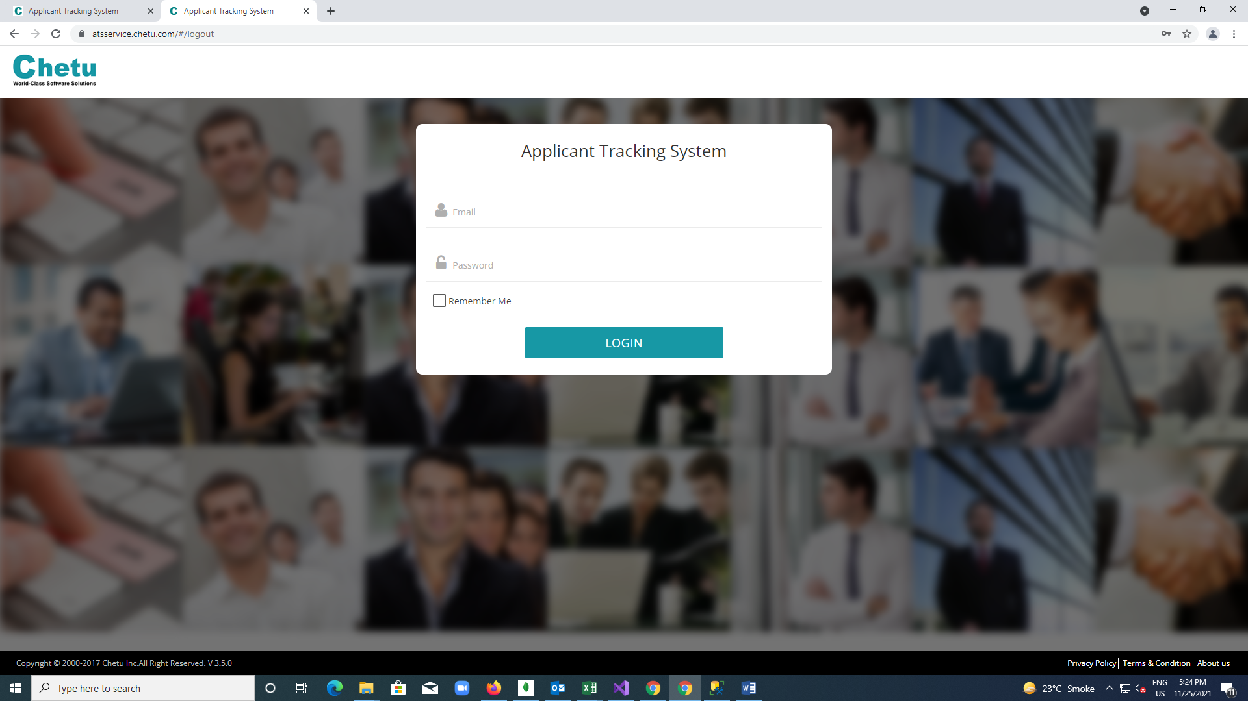

**Resourcing Module**

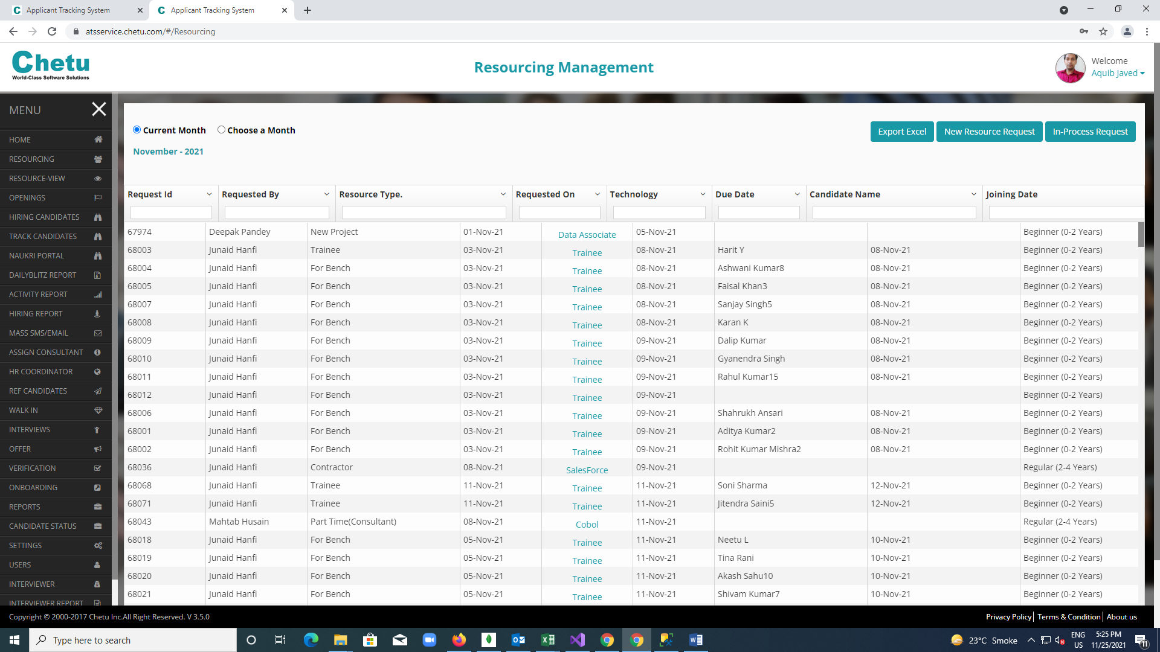

**New Resource Request**

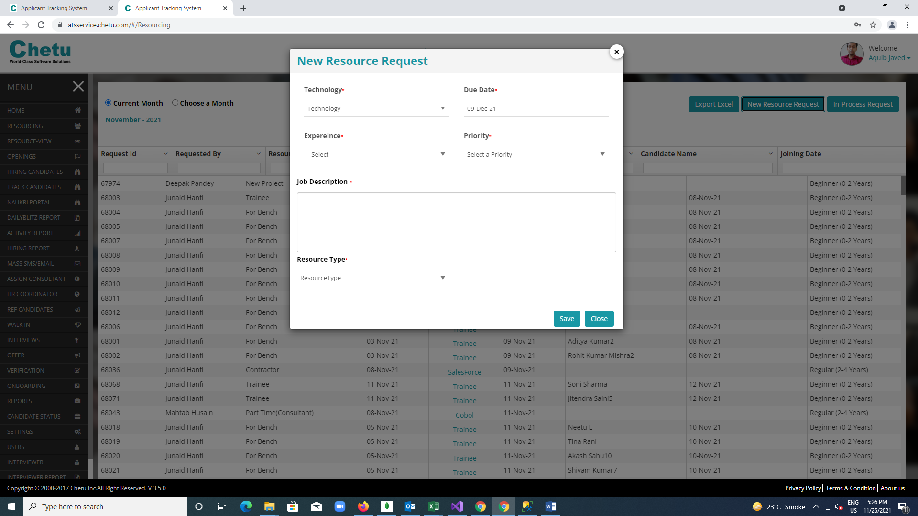

**Opening Module:**

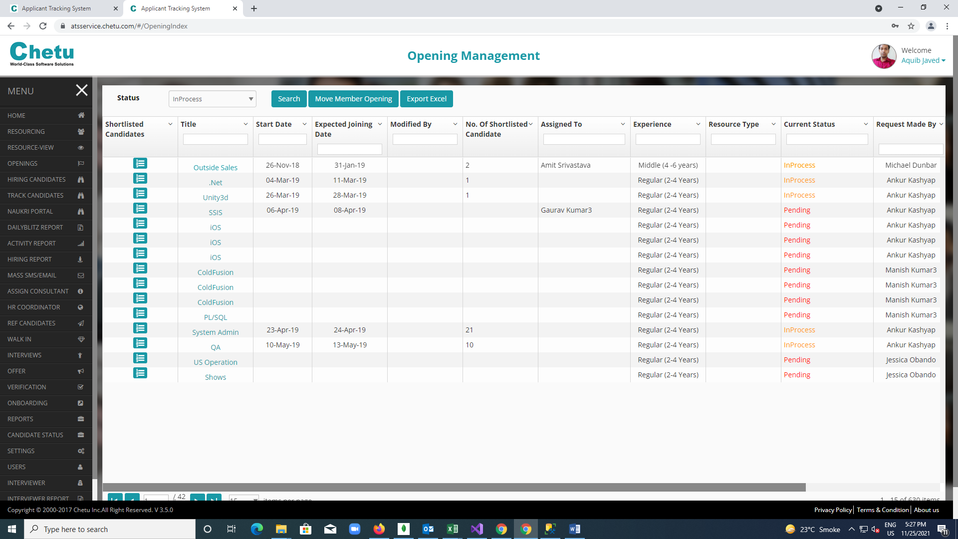

**Shortlisted Candidates:**

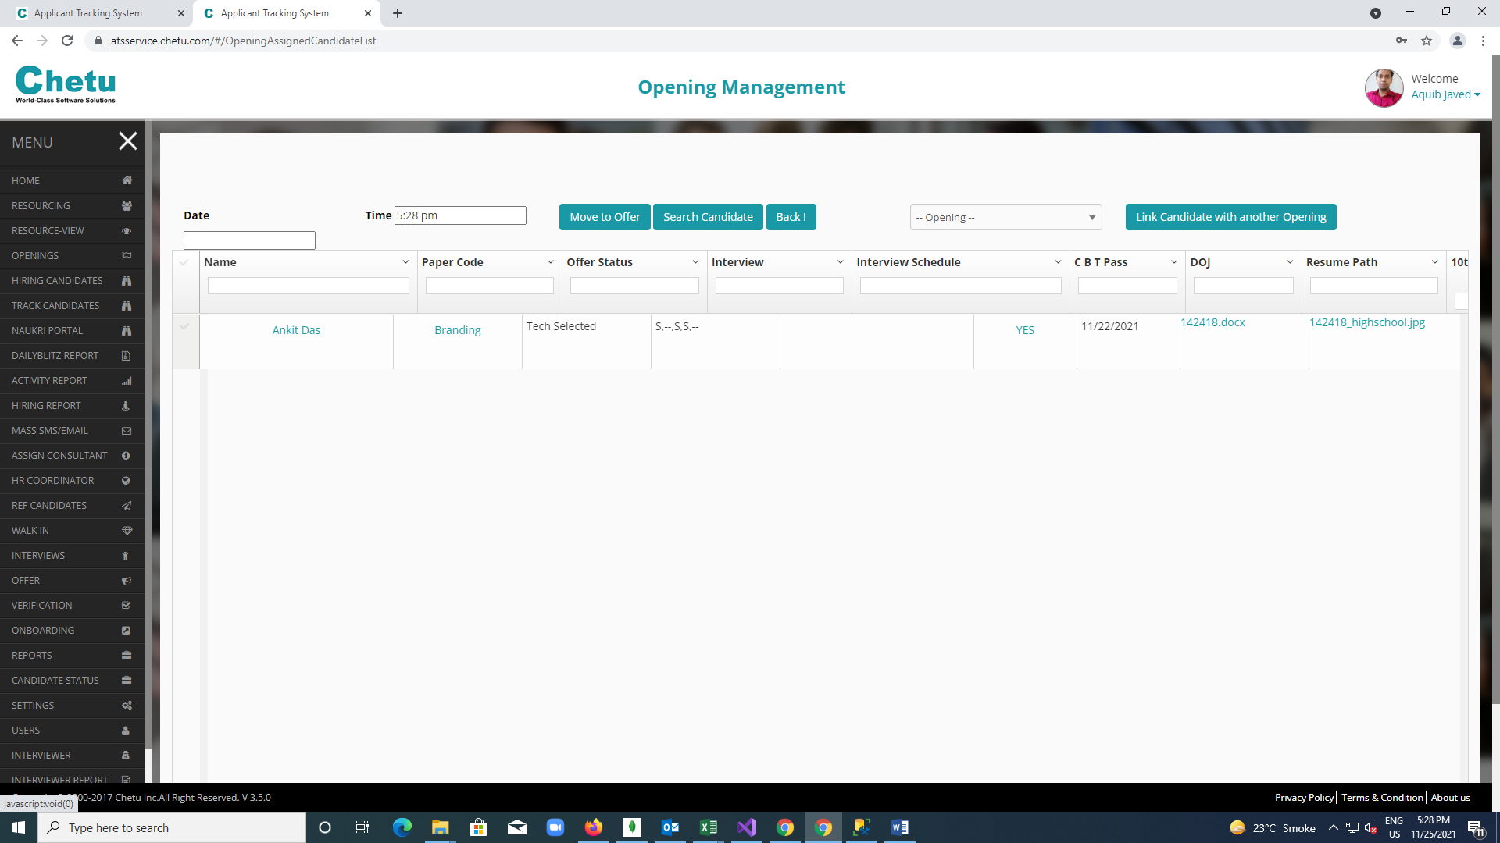

**Offer Module**

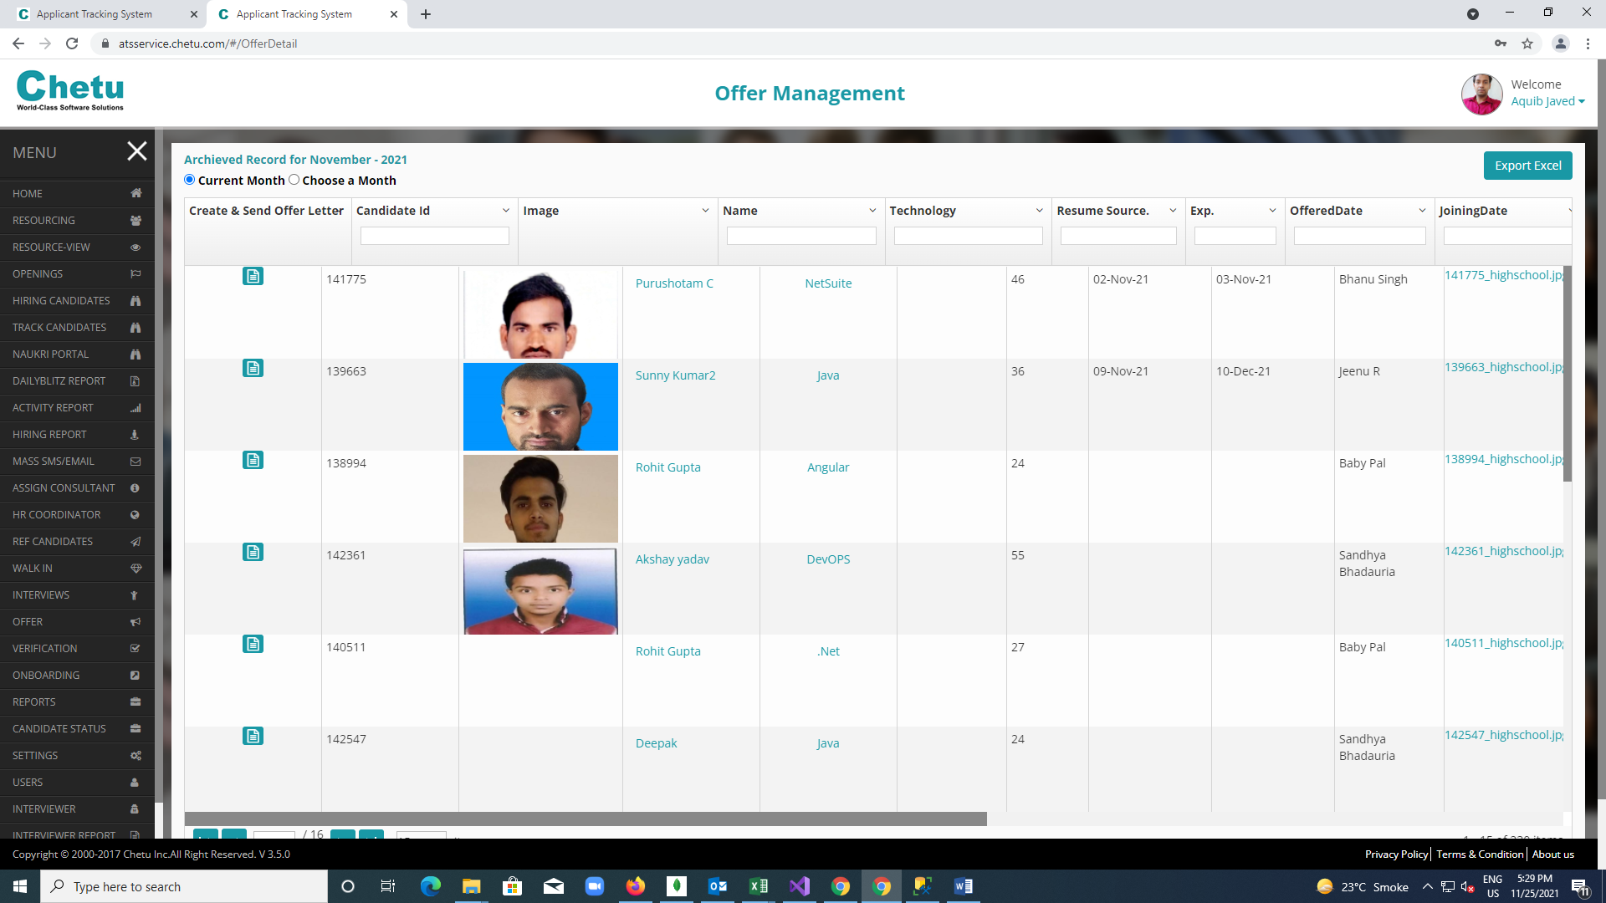

**Create offer letter section**

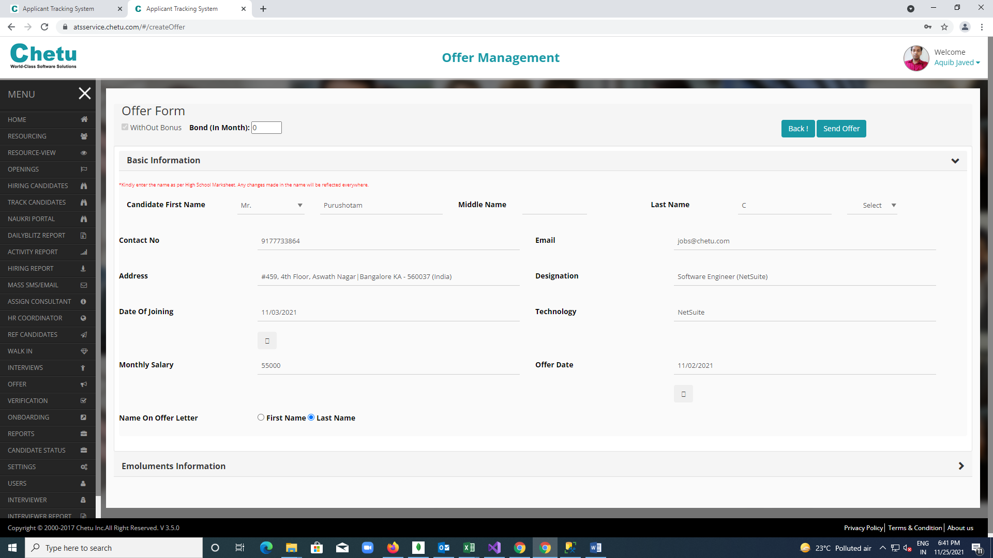

**Onboarding module** 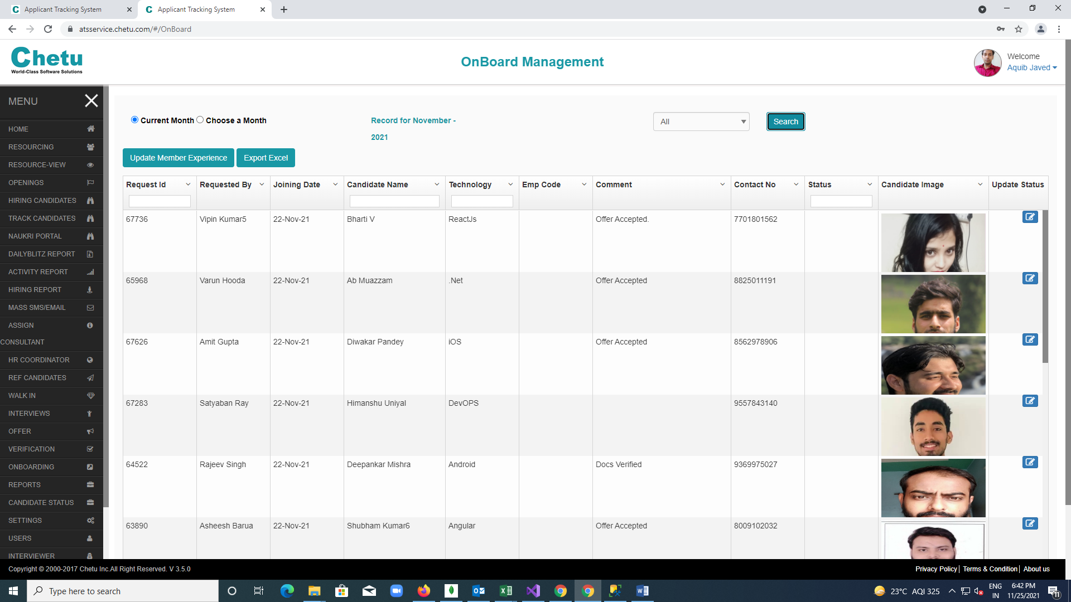

**Reporting module** 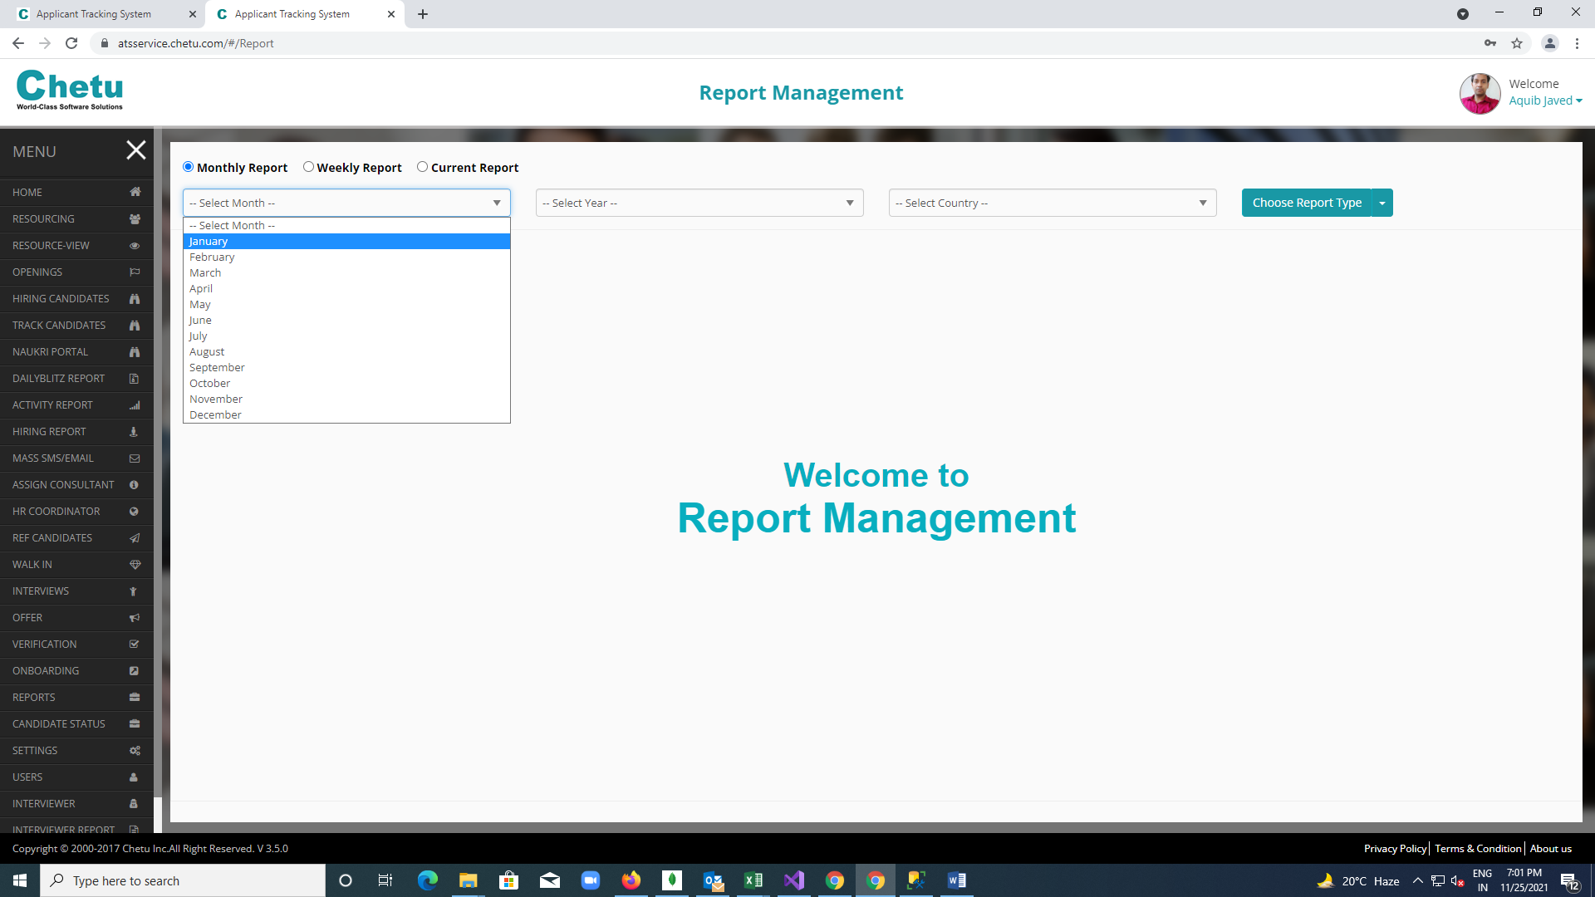

**User Module:**

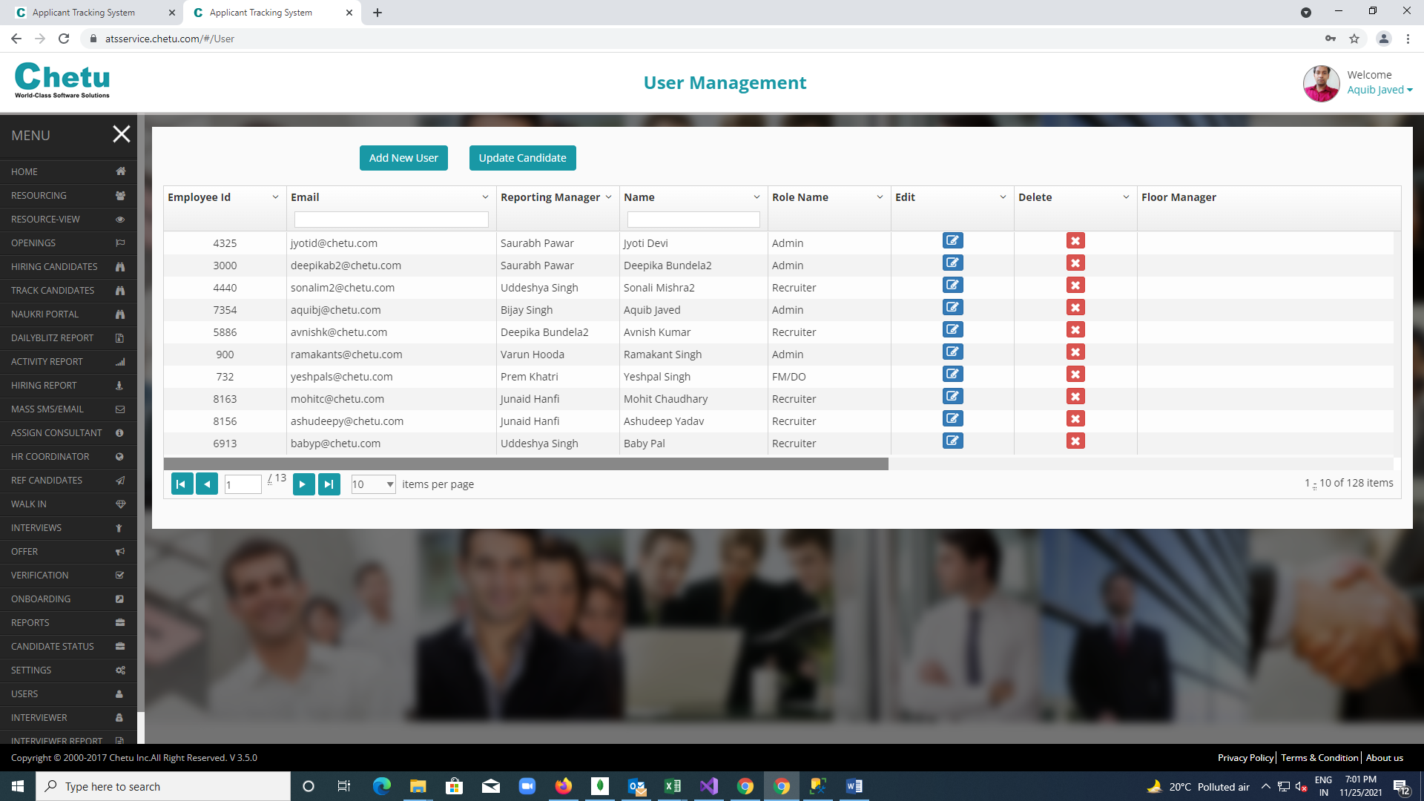

**Interviewer Module:**

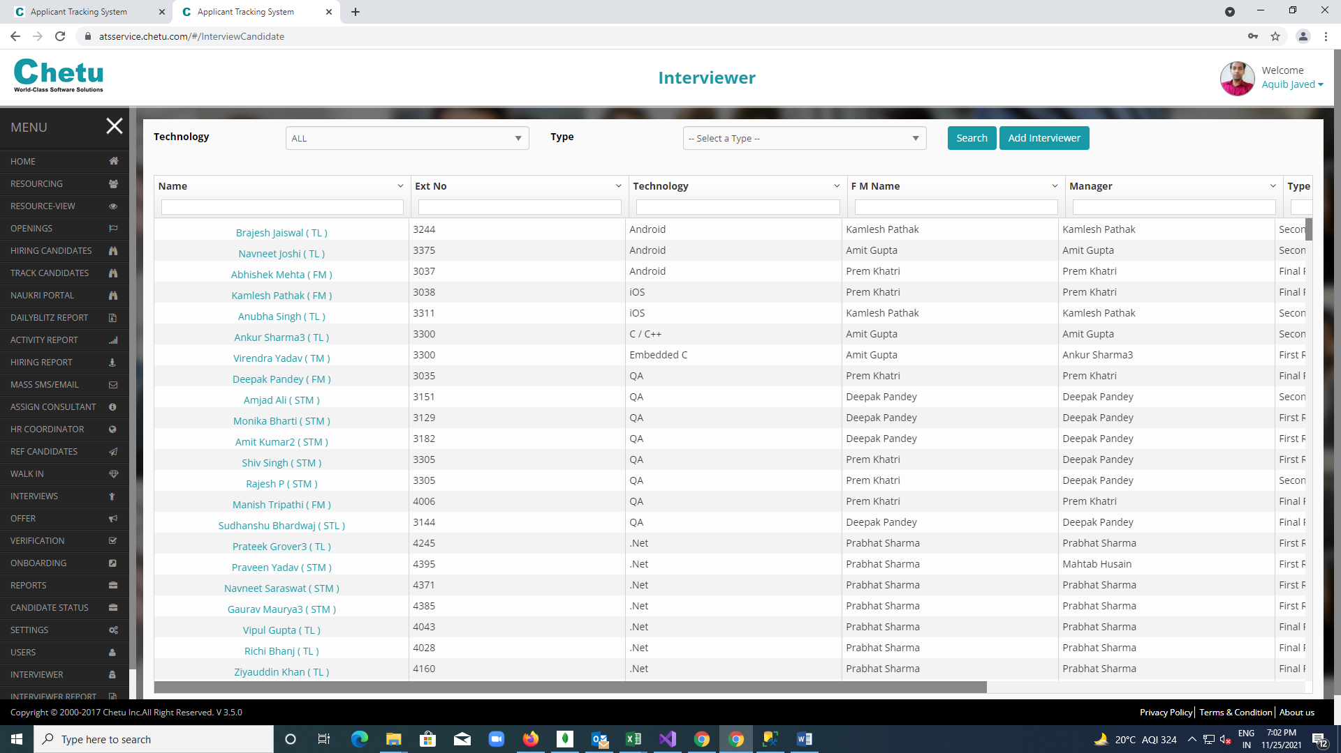

**Add interviewer schedule dialogue box:**

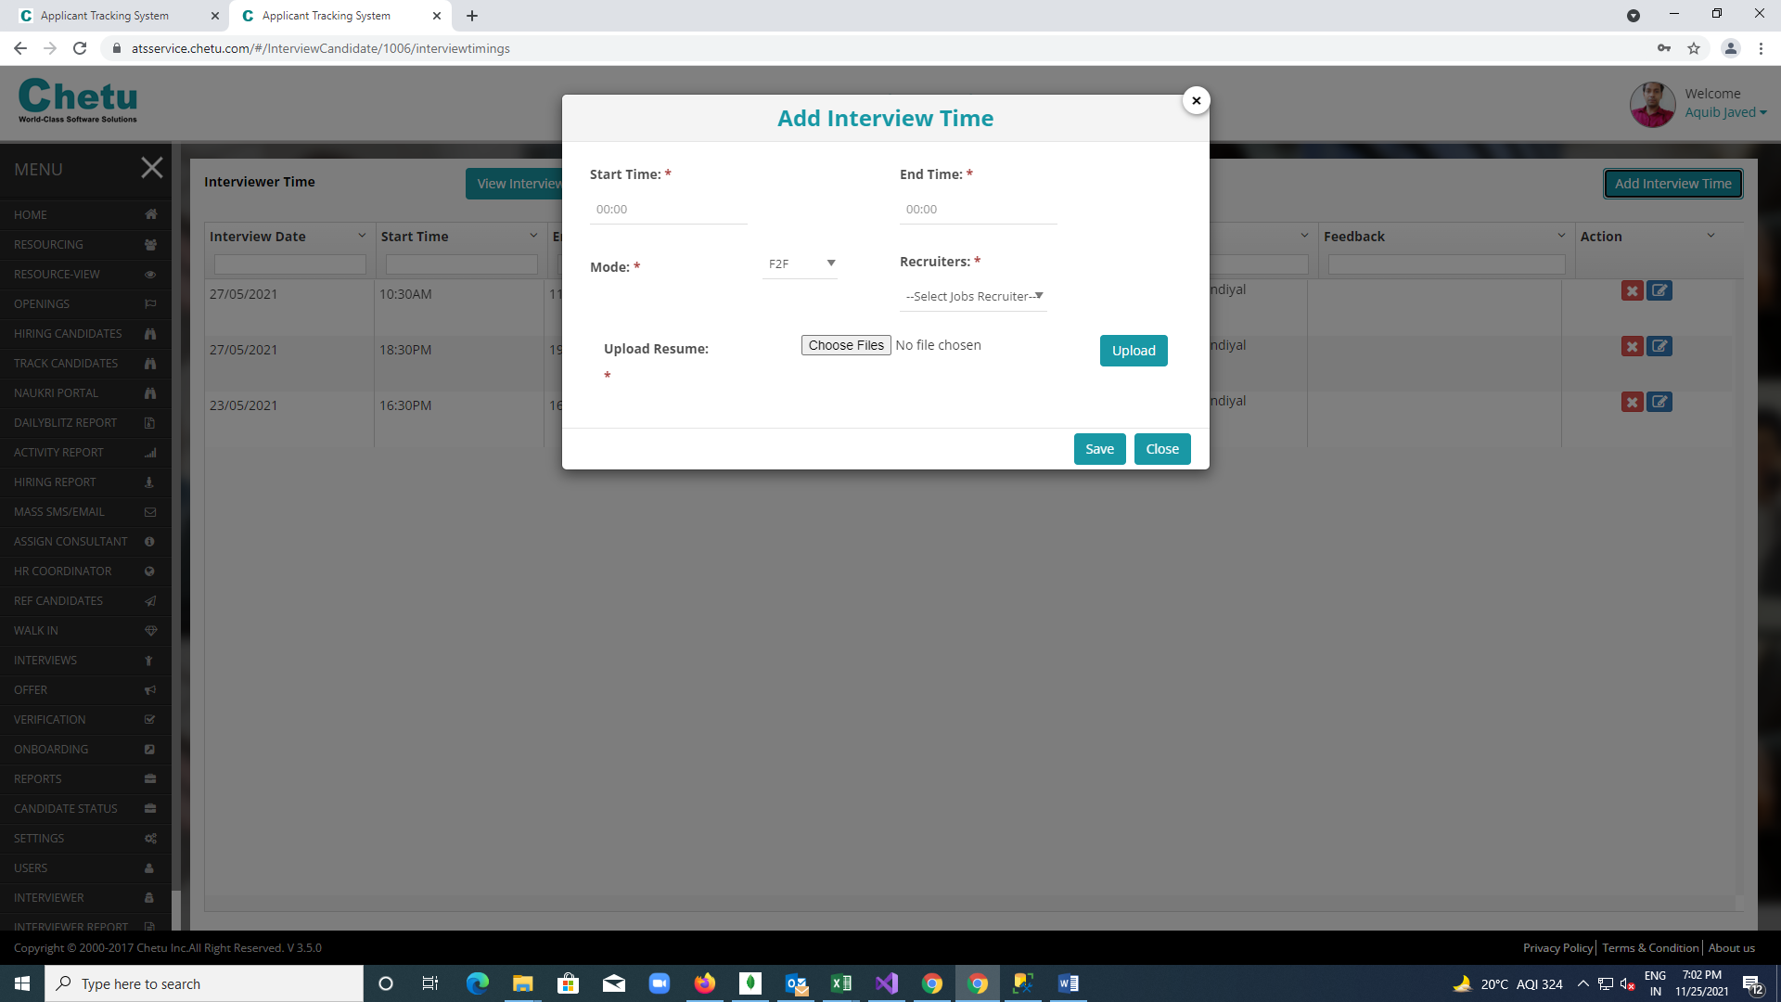

**Naukri Portal tab:-**

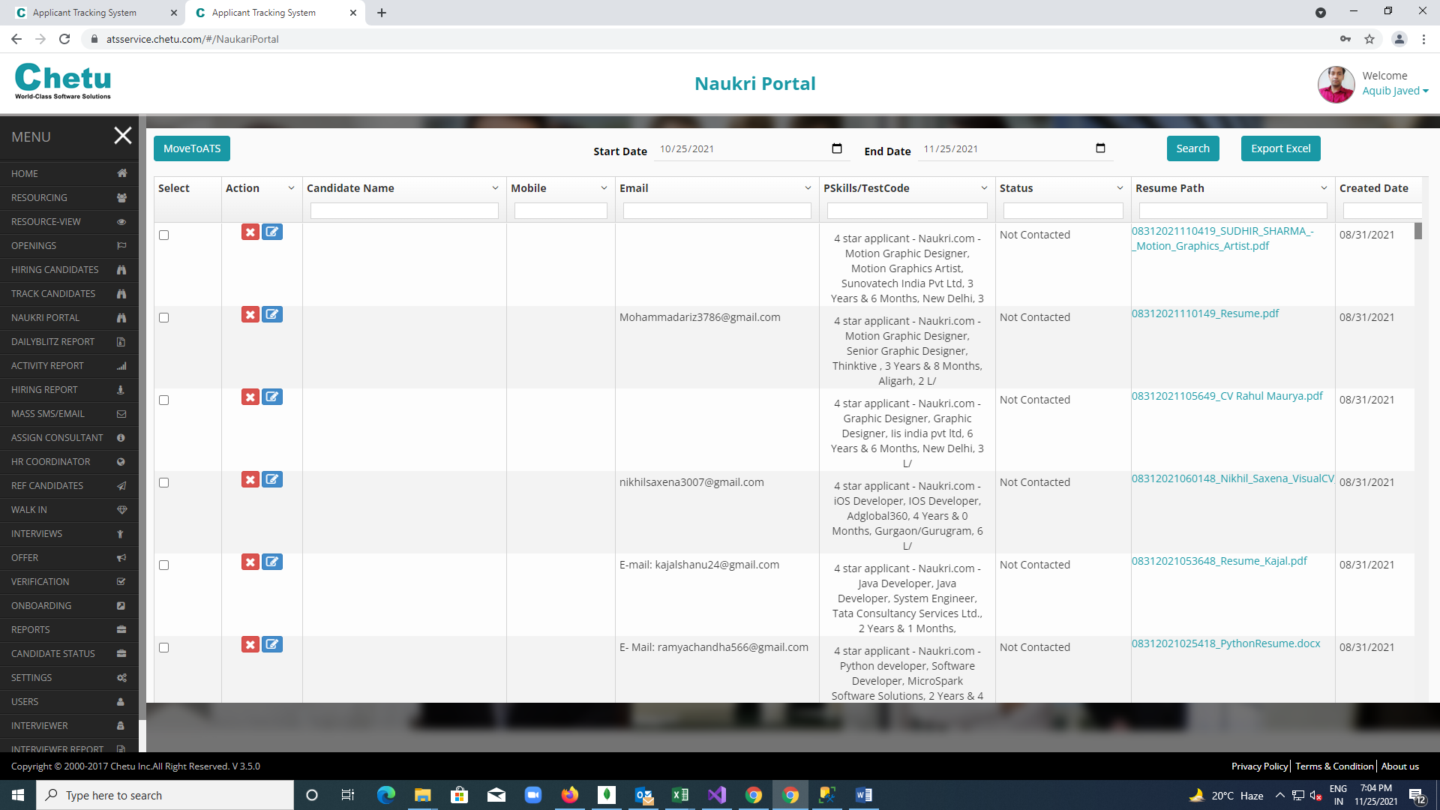

**Track Candidate tab:**

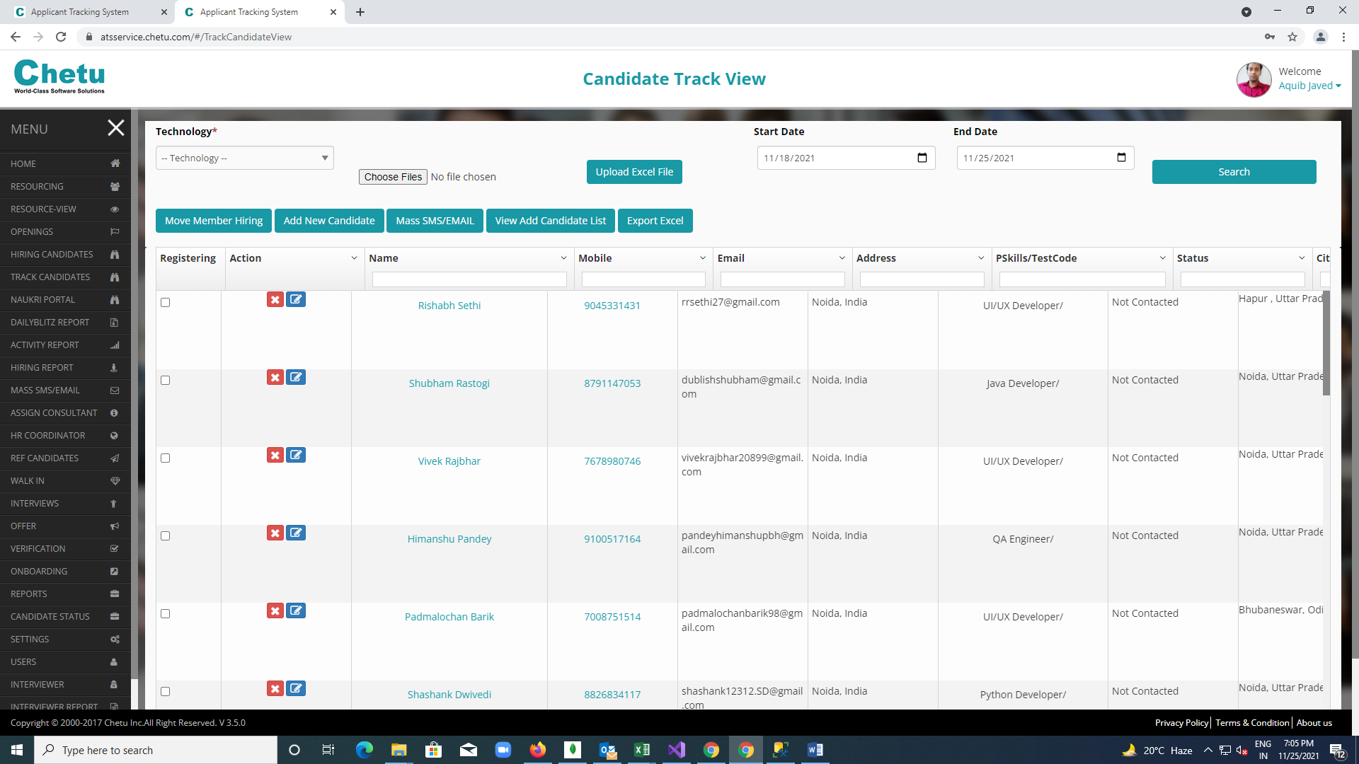

**Hiring Candidate tab:**

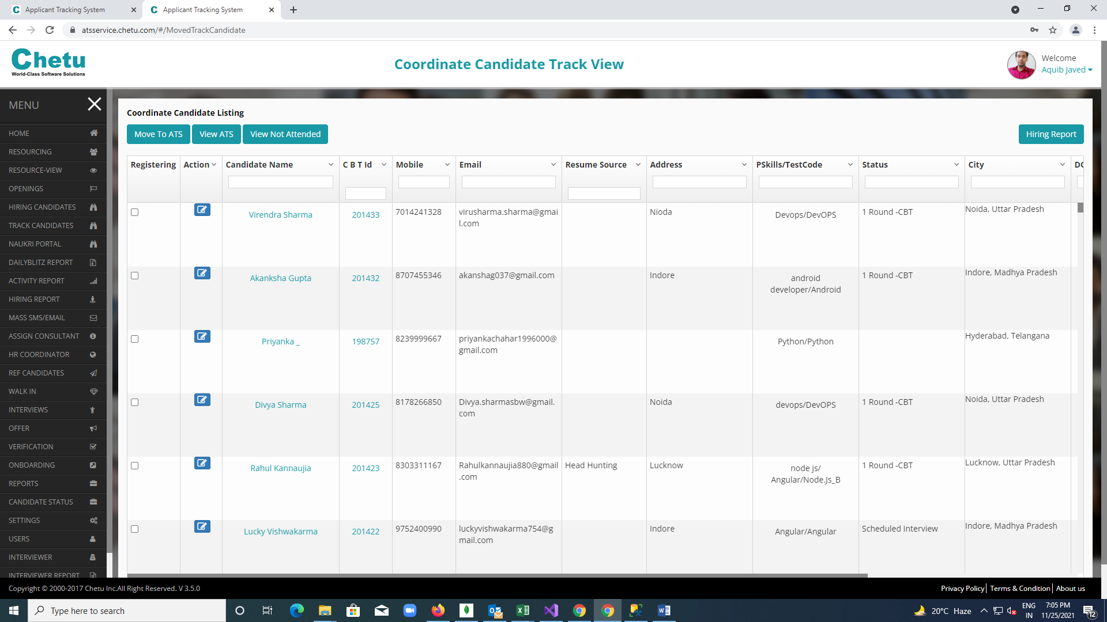

**Add new Candidate form:**

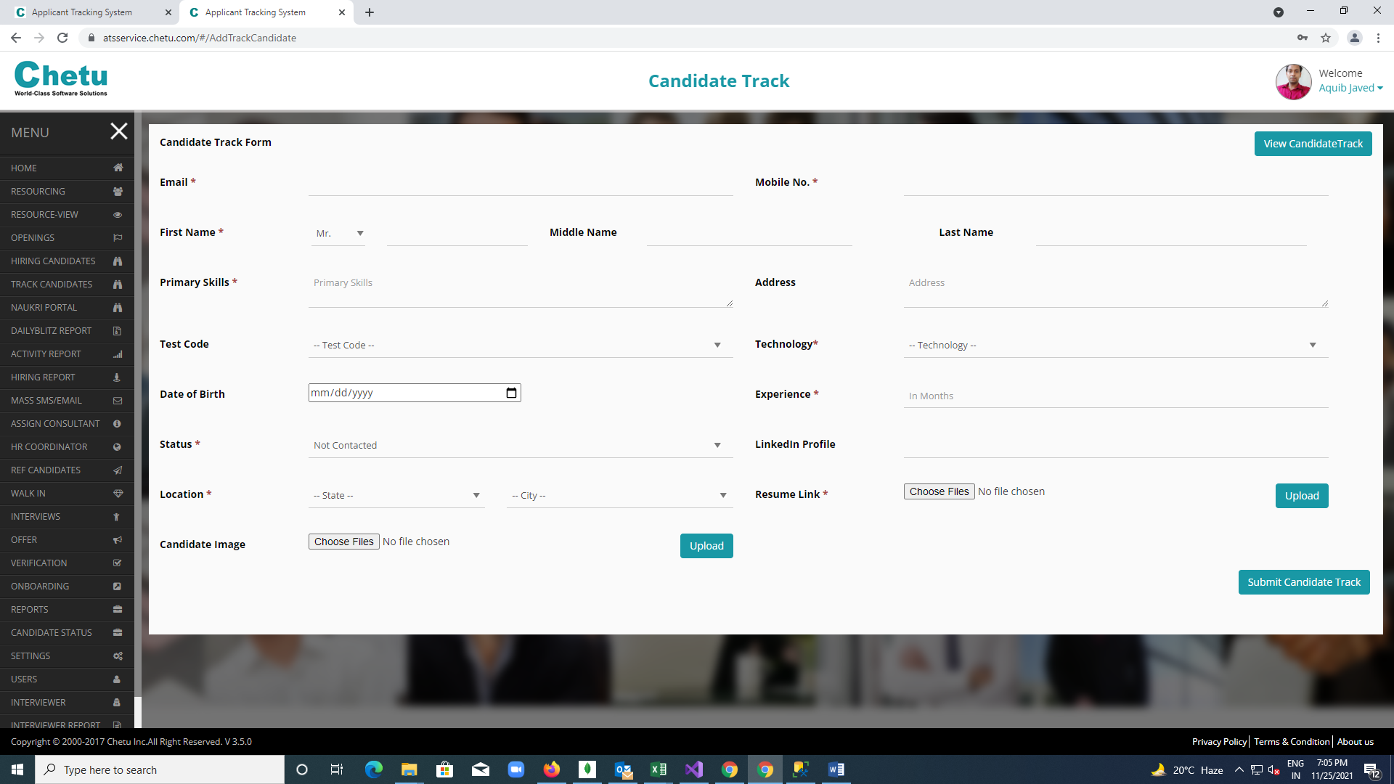

**ChetuHiring-INTL**

(subpart of ChetuGlobalATS-INTL)

**Production Details**

**Project Details**:-

* **URL:-** <http://hiring.chetu.com/>
* **Credentials:-** All Authorized members

**Database Details**:-

* **Server:-**APPDB01\APPDB01
* **Password:-** IT5ngr13v@123
* **Database Name:-** ats

**FTP Account Details**:-

* **IP**      :               10.0.0.32
* **Port**     :               990
* **User**     :               appdb01ftp
* **Pass**     :               a**dB01$@f6p2

**Description of the project**

**Login Page:-**

* Firstly, there is the **Login Page** which authenticate the user to use the application.

**Reports Tab:-**

* **Search button:** We can search a candidate using his/her Ref Id
* **Reset button:** It resets all the details on the frontend.
* **Enable test:** alit enables test for a candidate using his/her Ref id the details on the frontend.

**Receptionist Tab:-**

* Receptionist has the credential for this module. He/she can register a candidate from their own seat with webcam capturing the image of the candidate.

**Manage admin user Tab:-**

* The admin can add or remove the user from this tab. From here we can authenticate a user to use this application.

**Manage Question Tab:-**

* This module is used set questions for a given code of paper. A question is entered along with their four options and a correct answer.

**Manage Test paper Tab:-**

* This module is used to generate question papers with the help of questions that has been created in the manage question tab

**Export Report Tab:-**

* This button is used to generate reports of the candidate to the excel sheet

**Screenshots:-**

**Login Module**

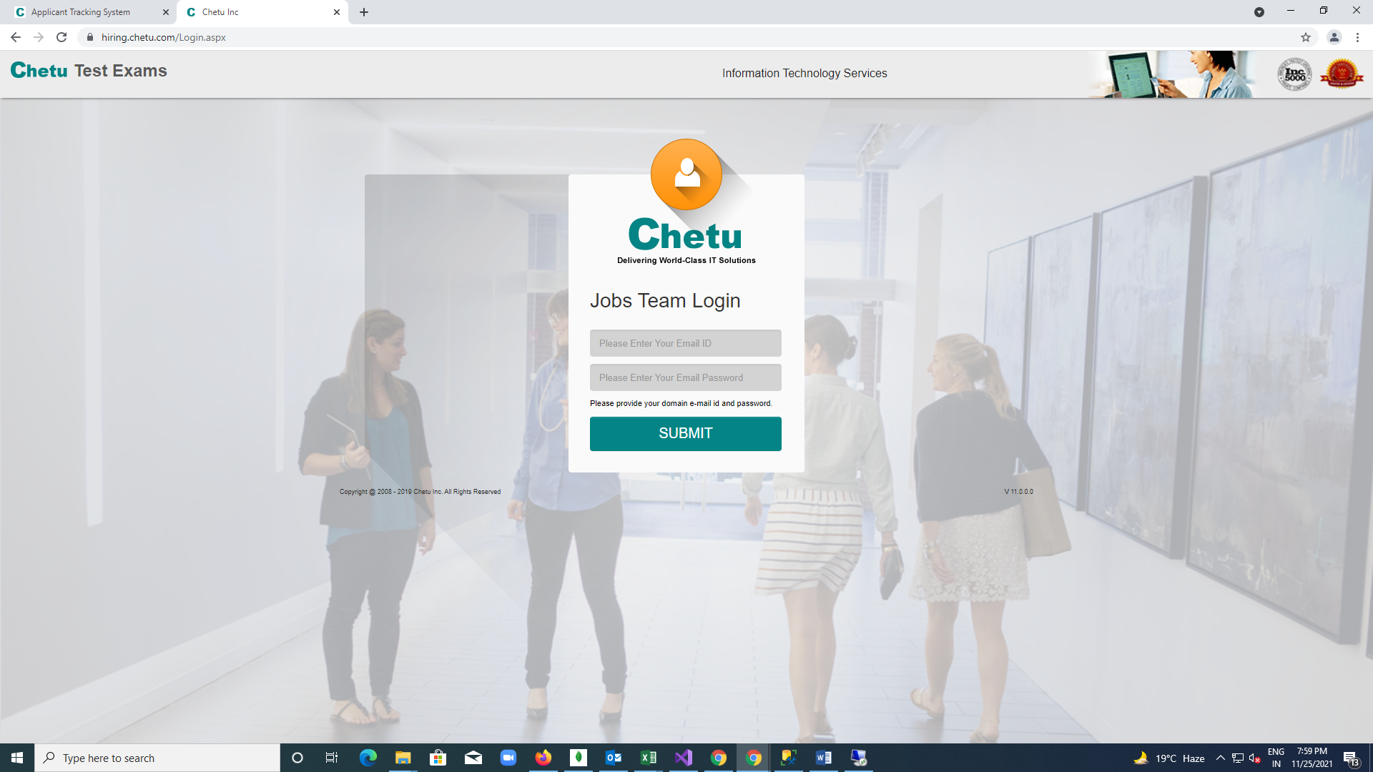

**Reports Module**

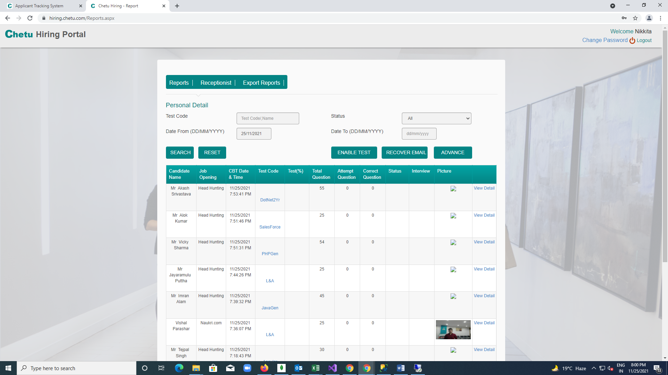

**Receptionist Module:**

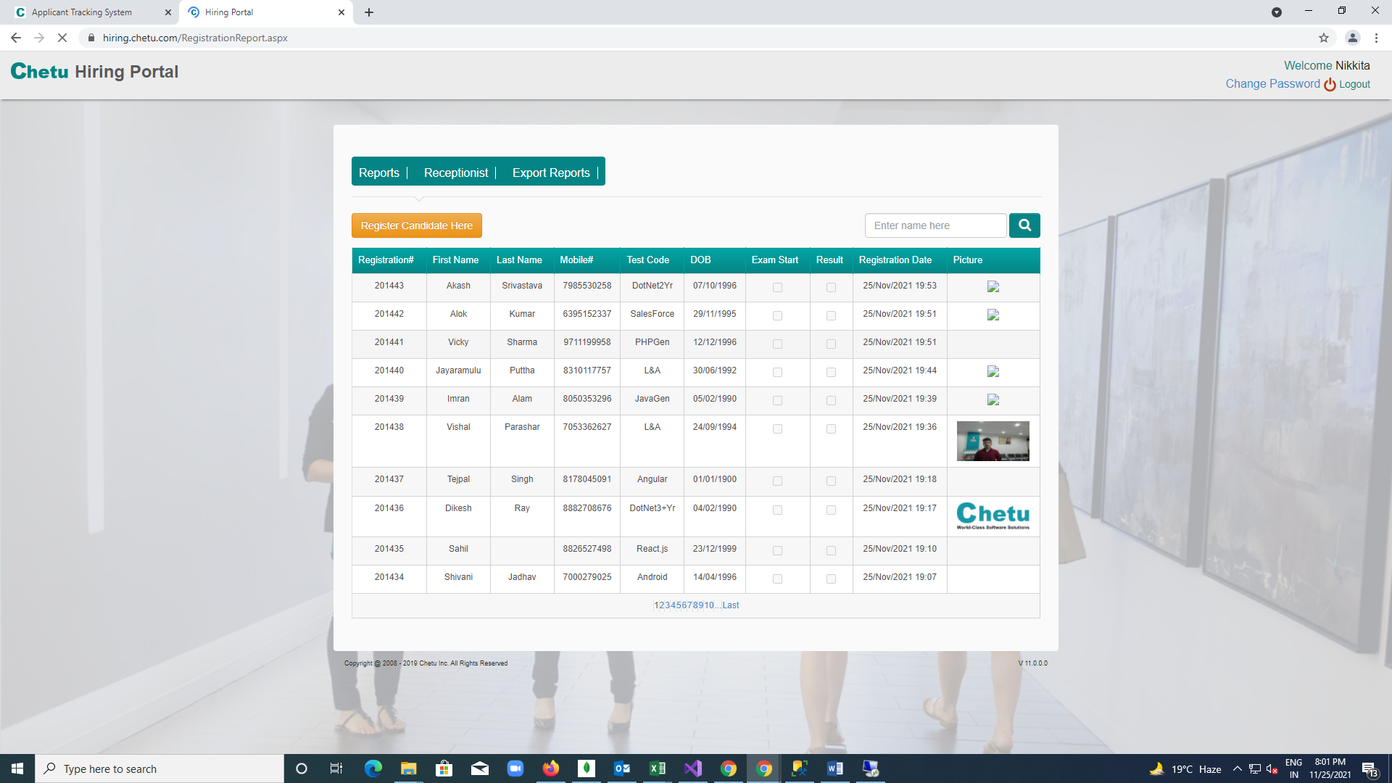

**Candidate Registration Form:**

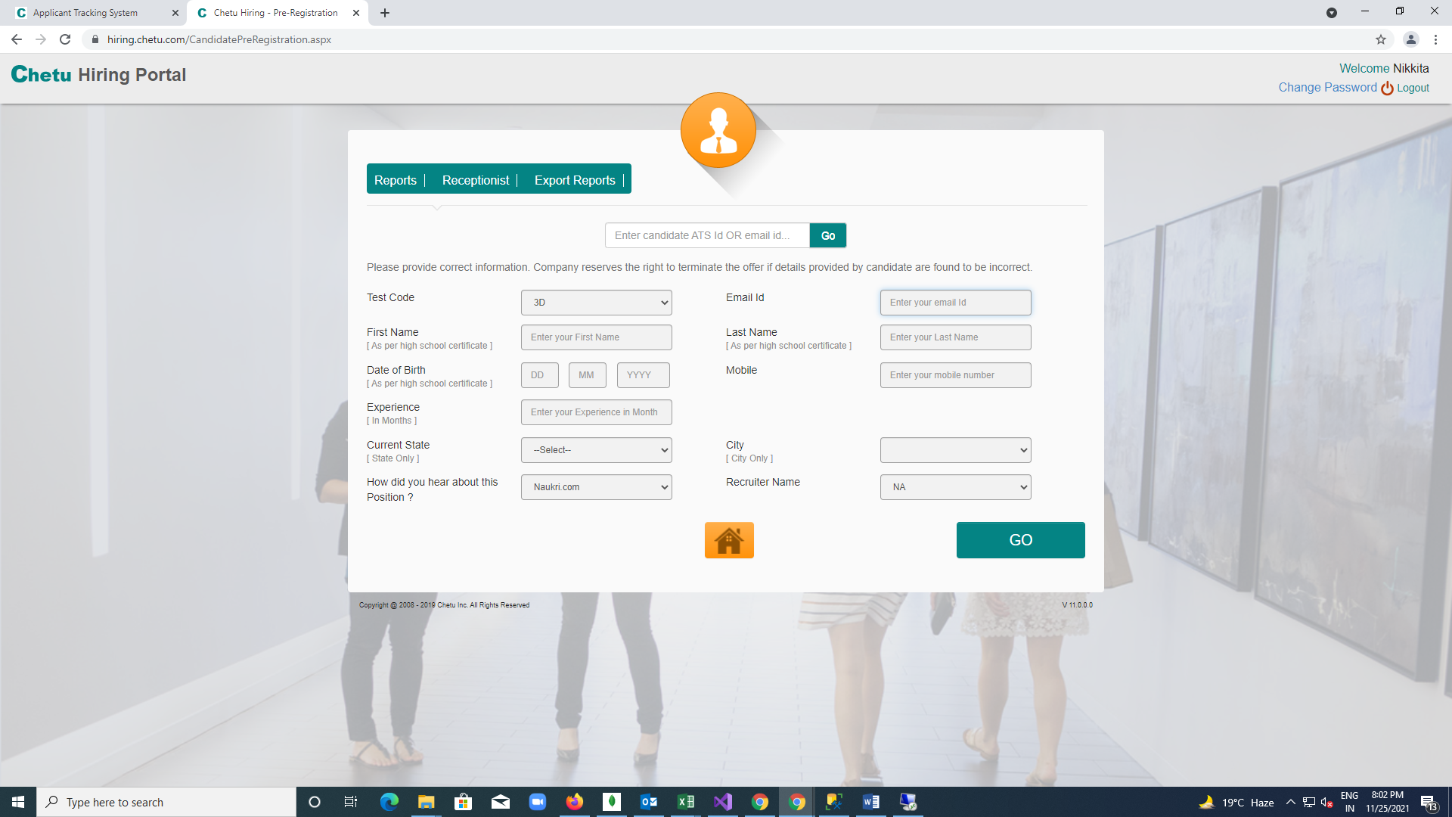

**Manage admin user:**

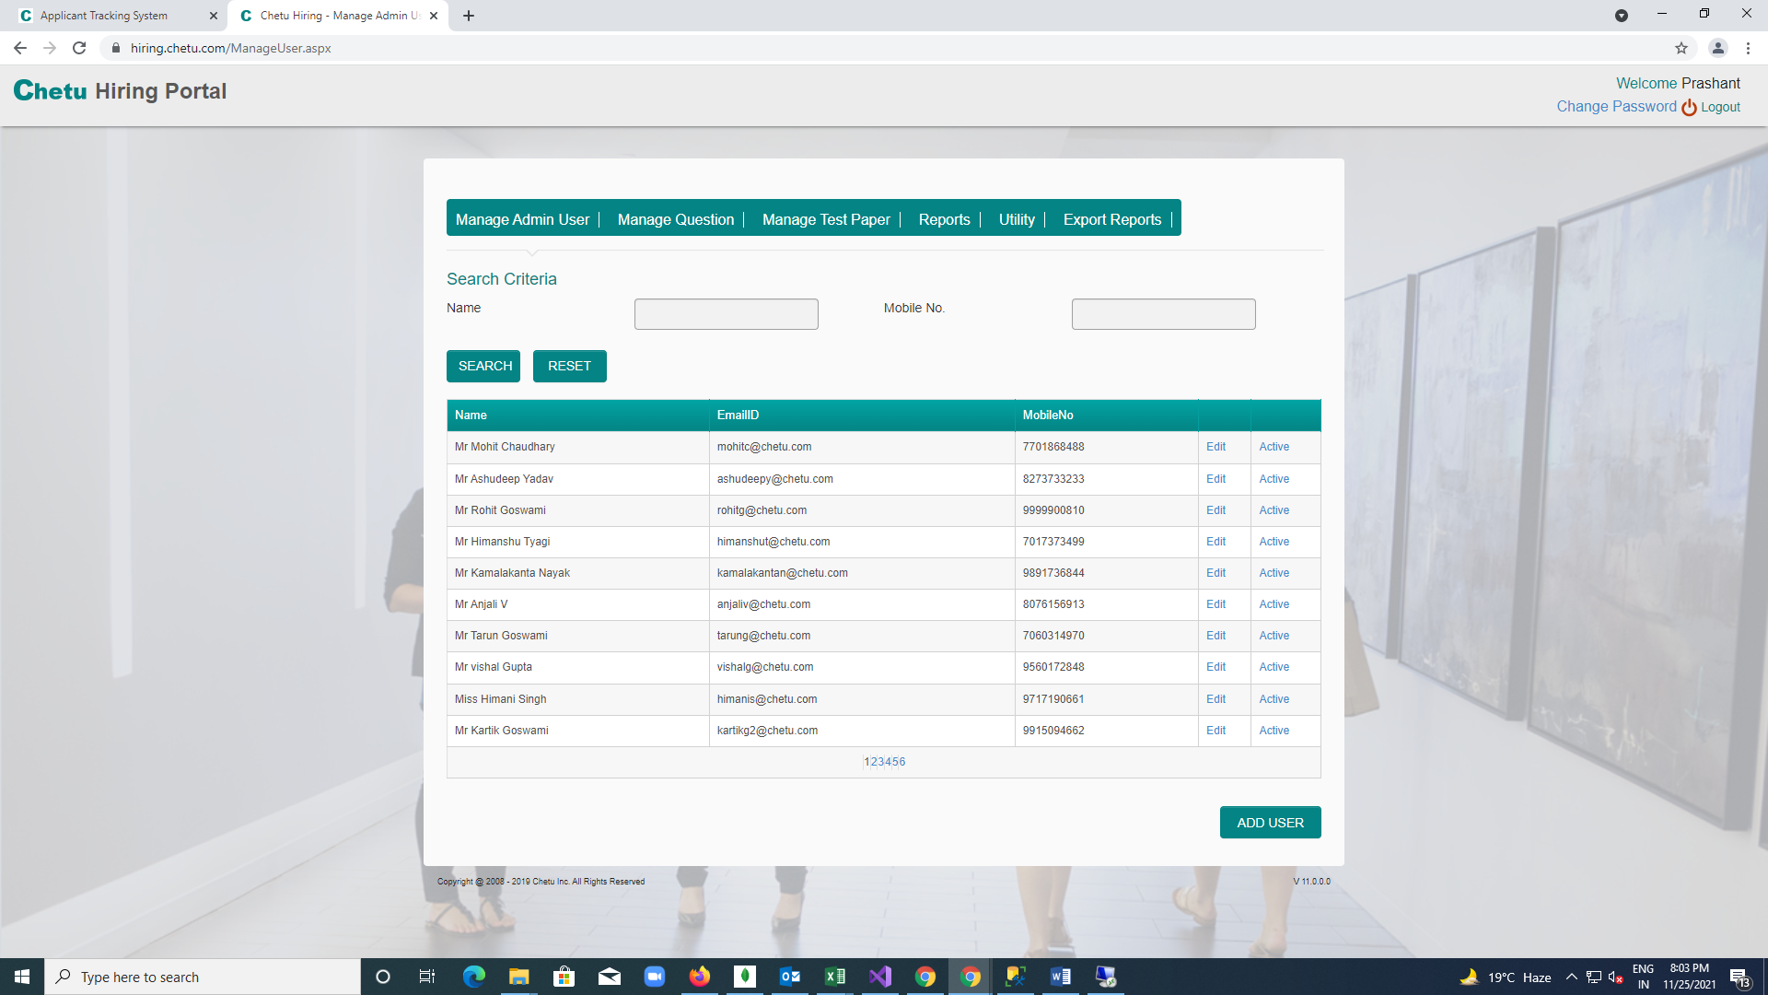

**Manage Question Module**

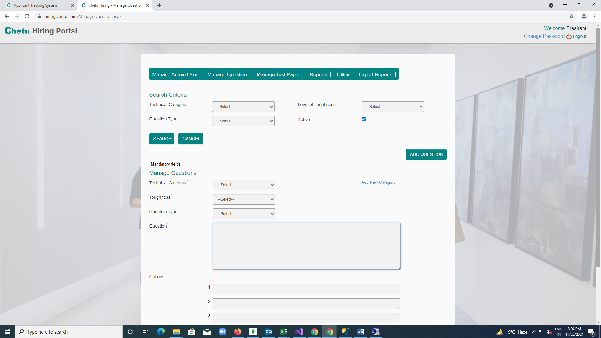

**Manage Test Paper Module:**

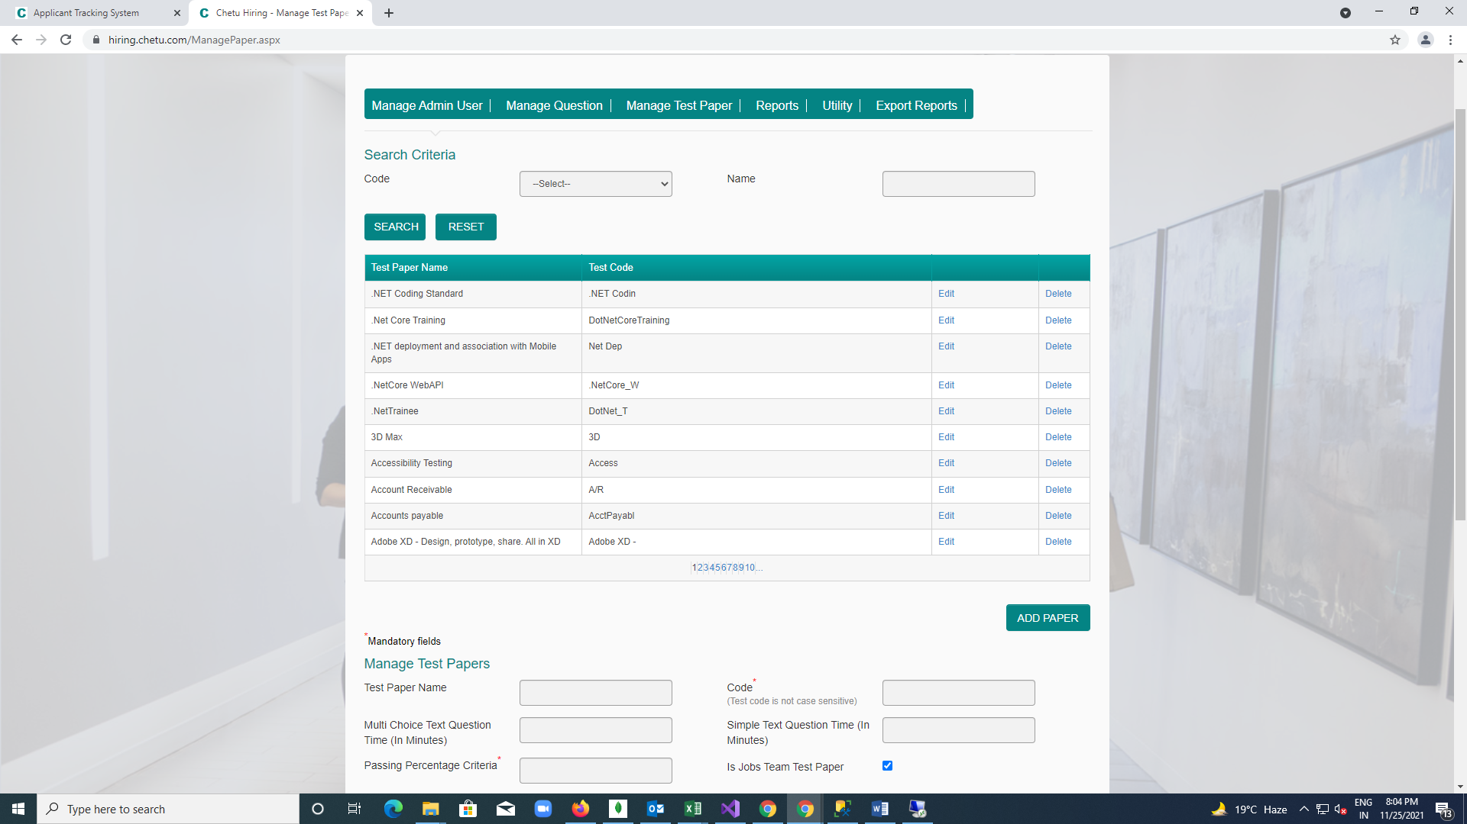

**Exports Report module**

